Weekly Work Report 11/8/2024

**Previous Feedback:**

* Implement **other models** from the paper as originally applied, specifically maintaining the **window size, using power spectral density features** instead of Statistical features (summary features), and utilizing **the same frequency bands** for each channel.
* Use **Statistical** **features** to train a **fully connected neural network**.

**This Week:**

* **The other 3 models and FCNN are used for classification.**
  + **Classification of Attentional States vs Rest States**
  + **Classification of Impasse States vs. Attentional States.**
  + **Classification of Aha! Moments vs. Attentional States.**
* **Completed EEG signal preprocessing to subject 61**

**Attentional state**

An attentional state is a state of **consciousness** in which a person **focuses** on specific environmental features to perform a task. It involves prioritizing task-relevant features over task-irrelevant ones.

Attentional states can occur in many situations, including:

* During activities like sports, music, writing, and meditation
* In situations of boredom
* In many professional fields, such as education and teaching

Attention is a combination of how long a person can focus and how many things they can focus on. There are two dimensions of attention: width (broad and narrow) and direction (internal and external). This results in four types of attentional control: external broad, internal broad, external narrow, and internal narrow.

Brain oscillations in the **alpha** and **theta** bands have been linked to attention and distraction. The hippocampus and medial prefrontal cortex (mPFC) are two brain regions that may establish memory-guided attentional states.

* **Literature Review**

*Kaushik, P., Moye, A., Vugt, M.v. et al. Decoding the cognitive states of attention and distraction in a real-life setting using EEG. Sci Rep 12, 20649 (2022). https://doi.org/10.1038/s41598-022-24417-w*

**Attentional state label:** EEG signals from Training dataset

* **Attentional States vs Rest States (Baseline)**

* The result is very good. Why? I believe the EEG signal in the baseline data resembles the exam data, as in both cases, subjects were focused on instructions and what they saw on the screen.
* Another reason is the absence of an exam tracking file with timestamped status recordings during training.
* **Attentional States vs Impasse States, Aha! Moments (**Power spectral density features),
* add # of frequency bands
* **(40, 16, (20 x 5))**



**EEGNet:** Frequency band features + Statistical features (Max, Min, Std, Mean)

**ML:** Frequency band features + Statistical features (Max, Min, Std, Mean)

Put same table, Features, ML, FCNN, Other NNs

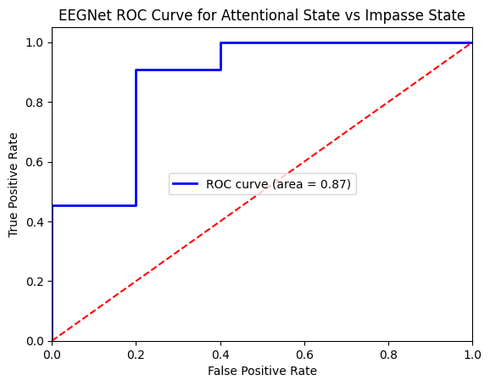

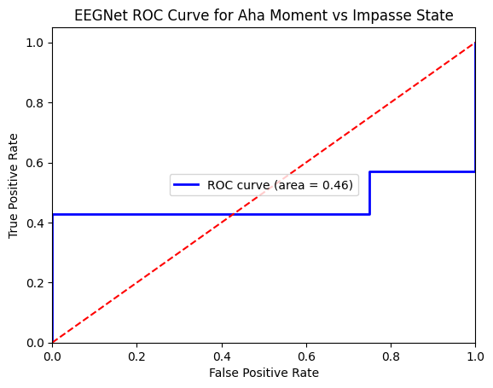

* **Literature Review**

*Liu N-H, Chiang C-Y, Chu H-C. Recognizing the Degree of Human Attention Using EEG Signals from Mobile Sensors. Sensors. 2013; 13(8):10273-10286. https://doi.org/10.3390/s130810273*

**FCNN: Statistical features only**

**Impasse vs Rest**

**Aha vs Rest**

**Aha vs Impasse**

**Overall Result**

**Put to same table, other NN**

**Add Column: features**

**Next Week:**

* Finish processing additional signals, including EDA and pupil data.
* Literature review: attention
* **Signals 🡪 2D image**
* [**https://en.wikipedia.org/wiki/Spectrogram**](https://en.wikipedia.org/wiki/Spectrogram)
* **Feature: Spectrogram**
* **To one table, show all the information**
* **Compare to other papers, result, same dataset**
* **Plot all ROC curve to one graph**
* **Different time window: 1s, 3s, 5s, 8s (Literature review), after**

**This Month:**

* Compare Aha!/Impasse/Attention classification using
  + physiology signals
  + EEG
  + physiology signals + EEG

**Final Goal:**

* Explore the dynamics of **Attention**, **Impasse**, and the **"Aha!"** moment.